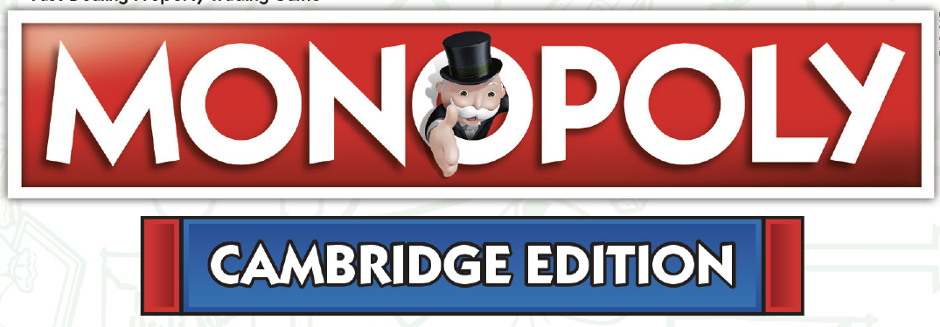
MONOPOLY UNVEILS THE FIRST ‘SMALL CITY’ U.S. EDITION WITH THE LAUNCH OF “CAMBRIDGE MONOPOLY ”
Cambridge Monopoly Officially Drops Locally in Stores and Online November 13th,
Just in Time for Holiday Gift Giving
CAMBRIDGE, MASS. (November 13, 2020): Today, MONOPOLY unveiled that Cambridge, Massachusetts, home to world-famous institutions Harvard University and MIT, and tech giants like Moderna has been immortalized with its very own official Cambridge MONOPOLY board at the Kimpton Hotel Marlowe.
The unveiling included the Mayor of Cambridge, Sumbul Siddiqui, along with an oversized representation of the board revealing the local squares such as as Mount Auburn Cemetery (the first garden cemetery in the United States), the newly redesigned Kimpton Marlowe Hotel, Longfellow House, and Graffiti Alley, and many more iconic educational institutions that make Cambridge, Massachusetts unique. Beginning today, Cambridge lovers and Cantabrigians alike can play the world’s most popular board game in a way that pays a fun tribute to the “City of Squares.”
MONOPOLY, the world’s most famous board game, for generations, has become a celebrated pastime for family and friends alike to play together. The official Cambridge MONOPOLY Board is now available locally on store shelves like Magic Beans, Cambridge, Porter Square Books and all local CVS locations as well as online retailers such as Amazon and Target -- just in time for the holidays and traditional family fun over the coming winter months.
Endorsing the project, Cambridge Mayor Siddiqui says, “We are excited about Monopoly’s newest edition of the game showcasing my hometown – Cambridge, Massachusetts. This edition will bring residents and non-residents together in exploring Cambridge’s beautiful, diverse, and rich history, all while playing this iconic game. Since we are all spending more time with our loved ones during this time, this game will bring fun and history home for all to enjoy. This is for the people of Cambridge and a celebration of all we’ve been and our dreams to come.”
Gifts that Give Back to the Community
In addition to celebrating local businesses, Top Trumps is also pleased to announce that three local charities have been chosen and will be represented with Community Chest cards -- we are excited to announce that the Cambridge Health Alliance, the American Repertory Theater (The A.R.T.) and Lovin’ Spoonfuls have been chosen to be included in the exclusive board design.
“When selecting the three charities we wanted to select those who are really helping and making an impact on the Cambridge Community -- daily,” say’s Top Trumps George Shrimpton. The Cambridge Health Alliance (CHA), a vibrant, innovative health system dedicated to providing essential services to all members of the community. With 140,000 patients, CHA is a local provider of choice for primary care, specialty care, emergency services, hospital care, and behavioral health. CHA patients receive high quality care in convenient neighborhood locations, and have seamless access to advanced care through CHA’s affiliation with Beth Israel Deaconess Medical Center.
Cambridge Health Alliance’s Director of Development, David Sternburg says, “It is exciting for CHA to partner with Top Trumps on a MONOPOLY game because; we appreciate being recognized for our vital role in maintaining the health and wellbeing of the people of Cambridge, as well as the other cities and towns CHA serves. When you land on a Community Chest playing MONOPOLY Cambridge, something beneficial happens for the player, which is an apt metaphor for the impact the CHA Foundationis having on the health of the Cambridge community. MONOPOLY is a game that brings people and families together, and CHA brings the Cambridge Community together to address social determinants of health and health inequalities.”
The edition will see locally themed squares replace Boardwalk and Park Place from the original MONOPOLY board and include customized ‘Community Chest’ and ‘Chance’ playing cards, making the entire game a truly local experience. Do expect official MONOPOLY iconic game tokens such as the top hat, car, and Scottie dog, and color sets will be dedicated to representing everything that makes Cambridge vibrant.
George Shrimpton of MONOPOLY said, “by asking for the public's participation, we wanted to ensure that Cambridge MONOPOLY is an accurate portrayal of what locals love about their city, so by having everyone submit their recommendations, we think we have accomplished just that. We are confident locals will be very proud. Anything and everything was up for consideration – from the Harvard Art Museum to Club Passim, Cambridge Common to MIT’s Great Dome, Border Cafe to Mr. Bartley's, and Memorial Drive to the scenic Charles River. We also chose three local charities to get their very own square.”
MONOPOLY first hit the shelves in 1935 – since then it has been played by more than 1 billion people. Today, it is played in 114 countries and enjoyed in nearly 50 different languages.
Photography: enclosed is photography of the official Monopoly Cambridge board for press purposes.
For media inquiries, please contact Chris Haynes at CBH Communications at chaynes@cbhcommunications.com or call directly to 617-256-5340. Interviews and quotes are available.

About Top Trumps
Top Trumps USA Inc. is a USA division of Winning Moves International. We make an assortment of world-famous educational card and board games. These include the original Top Trumps card game, Top Trumps Match - the Crazy Cube Game, Top Trumps Quiz, fast-paced word tile game Lexicon-GO!, playing cards &amp; puzzles. Top Trumps will now be bringing official versions of completely customized MONOPOLY for the North American market under license from Hasbro. Each community-based MONOPOLY experience will play homage to all of the favorite locations, icons, and businesses creating a game play that truly embraces what makes each community unique and special.

About Hasbro
Hasbro (NASDAQ: HAS) is a global play and entertainment company committed to Creating the World's Best Play and Entertainment Experiences. From toys, games and consumer products to television, movies, digital gaming, live action, music, and virtual reality experiences, Hasbro connects to global audiences by bringing to life great innovations, stories and brands across established and inventive platforms. Hasbro’s iconic brands include NERF, MAGIC: THE GATHERING, MY LITTLE PONY, TRANSFORMERS, PLAY-DOH, MONOPOLY, BABY ALIVE, POWER RANGERS, PEPPA PIG and PJ MASKS, as well as premier partner brands. Through its global entertainment studio, eOne, Hasbro is building its brands globally through great storytelling and content on all screens. Hasbro is committed to making the world a better place for all children and all families through corporate social responsibility and philanthropy. Hasbro ranked among the 2020 100 Best Corporate Citizens by 3BL Media and has been named one of the World’s Most Ethical Companies® by Ethisphere Institute for the past nine years. We routinely share important business and brand updates on our Investor Relations website, Newsroom and social channels (@Hasbro on Twitter and Instagram.)

# # #

